- Copyright for test papers and marking guides remains with West Australian Test Papers.
- The papers may only be reproduced within the purchasing school according to the advertised conditions of sale.
- Test papers must be withdrawn after use and stored securely in the school until Friday June 14

Insert School Logo
HUMAN BIOLOGY
Unit 1
2019

Name: _______________________________________________________

Teacher: ___________________________________________________

Time allowed for this paper

Reading time before commencing work: ten minutes
Working time for the paper: three hours

Materials required/recommended for this paper
To be provided by the supervisor
This Question/Answer booklet
Multiple-choice answer sheet

To be provided by the candidate:
Standard items: pens (blue/black preferred), pencils (including coloured), sharpener, correction fluid/tape, eraser, ruler, highlighters

Special items: non-programmable calculators approved for use in this examination

Important note to candidates
No other items may be taken into the examination room. It is your responsibility to ensure that you do not have any unauthorised material. If you have any unauthorised material with you, hand it to the supervisor before reading any further.

Structure of this paper

Section | Number of questions available | Number of questions to be attempted | Suggested working time (minutes) | Marks available | Percentage of examination
Section One  Multiple-choice | 30 | 30 | 40 | 30 | 30
Section Two  Short answer | 8 | 8 | 90 | 106 | 50
Section Three  Extended answer | 3 | 2 | 50 | 40 | 20
 |  |  |  | Total | 100

Instructions to candidates

1. The rules for the conduct of the Western Australian examinations are detailed in the Year 12 Information Handbook 2019. Sitting this examination implies that you agree to abide by these rules.

2. Write your answers in this Question/Answer booklet preferably using a blue/black pen. Do not use erasable or gel pens.

3. Answer the questions according to the following instructions.

Section One: Answer all questions on the separate Multiple-choice answer sheet provided. For each question, shade the box to indicate your answer. Use only a blue or black pen to shade the boxes. Do not use erasable or gel pens. If you make a mistake, place a cross through that square, then shade your new answer. Do not erase or use correction fluid/tape. Marks will not be deducted for incorrect answers. No marks will be given if more than one answer is completed for any question.

Section Two: Write your answers in this Question/Answer booklet. Wherever possible, confine your answers to the line spaces provided.

Section Three: Consists of three questions. You must answer two questions. Tick the box next to the question you are answering. Write your answers in this Question/Answer booklet.

4. You must be careful to confine your answers to the specific questions asked and to follow any instructions that are specific to a particular question.

5. Supplementary pages for planning/continuing your answers to questions are provided at the end of this Question/Answer booklet. If you use these pages to continue an answer, indicate at the original answer where the answer is continued, i.e. give the page number.

Section One: Multiple-choice 30% (30 Marks)

This section has 30 questions. Answer all questions on the separate Multiple-choice Answer Sheet provided. For each question shade the box to indicate your answer. Use only a blue or black pen to shade the boxes. Do not use erasable or gel pens. If you make a mistake, place a cross through that square, then shade your new answer. Do not erase or use correction fluid/tape. Marks will not be deducted for incorrect answers. No marks will be given if more than one answer is completed for any question.

Suggested working time: 40 minutes.

- Erythrocytes (red blood cells) lack most of the membrane bound organelles found in other mature body cells. Which of the following processes are erythrocytes able to carry out?

  - Protein synthesis
  - Glycolysis
  - Electron Transport Chain
  - Cell division

- In August 2016, Science in Australia Gender Equality released statistics stating that out of 220 162 students studying STEM, 72 911 were women. Which of the following best represents the ratio between females and males studying STEM?

  - 1:2
  - 2:1
  - 1:3
  - 3:1

- In which of the following parts of the body would you expect to find the least number of Golgi bodies?

  - Muscles
  - Salivary glands
  - Small Intestine
  - Stomach

- The Fluid Mosaic Model of the cell membrane refers to the

  - variety of proteins that are found within the membrane.
  - ability of substances to pass through the membrane.
  - arrangement of the phospholipids into a bilayer.
  - diverse number of components and their ability to move positions.

Question 5 and 6 refer to the diagram below:
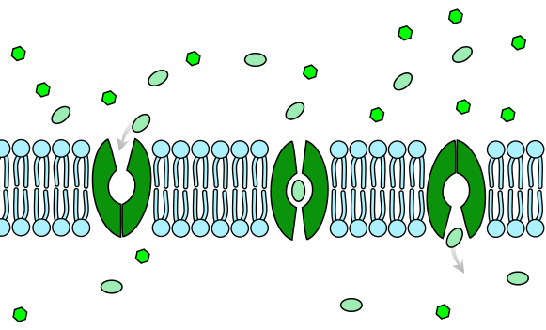

- The diagram above shows the movement of a substance into a cell. Which description best describes the movement of this substance?

  - No energy (ATP) is required, as the substance is moving against the concentration gradient
  - Energy (ATP) is required, as the substance is moving against the concentration gradient
  - No energy (ATP) is required, as the substance is moving with the concentration gradient
  - Energy (ATP) is required, as the substance is moving with the concentration gradient

- The type of transport best represented by the diagram above is referred to as

  - simple diffusion.
  - facilitated diffusion.
  - active transport.
  - vesicular transport.

- Muscles work in pairs known as

  - agonistic pairs.
  - antagonistic pairs.
  - synergistic pairs.
  - stabilising pairs.

- A patient with blood type A requires a transfusion. Which of the following lists the blood types that this patient can receive?

- Blood types A and O
- Blood types AB and A
- Blood types AB and O
- Blood types AB, A and O

- Emphysema is a respiratory disease often associated with chronic smokers, where irritating particles damage the alveoli. Sufferers struggle to take in enough oxygen and often are fatigued. These symptoms are best attributed to

  - constriction of the alveoli and damage to the blood vessels surrounding the lungs.
  - decreased surface area within the lungs and poor ventilation.
  - vasoconstriction of the respiratory capillaries and reduced lung volume.
  - loss of fluid covering the lungs and increased thickness of the alveolar membranes.

- The functions of the muscular system include all of the following except

  - produce movement.
  - maintain posture.
  - produce heat.
  - protect internal organs.

- Blood clotting disorders, such as haemophilia, are often treated with blood transfusions containing

  - plasma only.
  - whole blood.
  - platelet concentrates.
- red cell concentrates.

- Which of the following correctly states the functional and structural classification of the following joints?

 | Joint | Functional | Structural
- (a) | Skull | Fixed joint | Fibrous
(b) | Elbow | Slightly moveable | Synovial
(c) | Adjacent vertebrae | Cartilaginous | Slightly moveable
(d) | Wrist | Synovial | Freely moveable

- The shaft of the long bone is known as the

  - epiphysis.
  - diaphysis.
  - periosteum.
  - endosteum.

- Which of the following sets of muscles are responsible for the action of inhalation in humans?

  - External intercostal muscles and diaphragm
  - Diaphragm only
  - Internal intercostal muscles and diaphragm
  - External and internal intercostal muscles

- During aerobic respiration, the Krebs (or Citric Acid) cycle and Electron Transport Chain (ETC) occur. Which of the following states the correct location of these processes within the mitochondria?

  - Both the Krebs Cycle and ETC occur in the matrix
  - The Krebs Cycle occurs on the inner membrane whilst the ETC occurs in the matrix
  - Both the Krebs Cycle and ETC occur on the inner membrane
  - The Krebs Cycle occurs in the matrix whilst the ETC occurs on the inner membrane

- Which of the following correctly states the nutrient, its basic structural unit and main function?

 | Nutrient | Structural Unit | Function
- (a) | Protein | Nucleotides | Enzymes
(b) | Lipid | Fatty Acids and Glycerol | Energy source
(c) | Carbohydrate | Monosaccharides | Co-enzymes
(d) | Vitamin | Amino acids | Solvent

- Muscle tissue which shows a lack of striations is known as

  - smooth muscle.
  - skeletal muscle.
  - cardiac muscle.
  - voluntary muscle.

- Athletes competing in a race are often given a glucose drink rather than sucrose to keep their energy levels up. The best reason for this is that glucose is

  - a complex carbohydrate and therefore contains more energy per molecule than sucrose.
  - the only nutrient that can be converted to energy during cellular respiration.
  - lipid-soluble, therefore easily digested and absorbed by the digestive tract.
  - the simplest form of carbohydrate and therefore does not require any further digestion.

Question 19 refers to the diagram below:

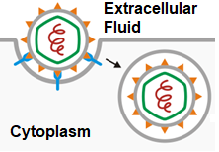

- The cellular process depicted above is best explained as

  - endocytosis; material is surrounded by the plasma membrane and buds off outside the cell forming a vesicle.
  - endocytosis; material is surrounded by the plasma membrane and buds off inside the cell forming a vesicle.
  - exocytosis; material is surrounded by the plasma membrane and buds off outside the cell forming a vesicle.
  - exocytosis; material is surrounded by the plasma membrane and buds off inside the cell forming a vesicle.

- The inner lining of the trachea and kidney tubules is made up of

  - epithelial tissue.
  - nervous tissue.
  - muscle tissue.
  - connective tissue.

- The major difference between vitamins and minerals is

  - minerals can be broken down by heat, whilst vitamins cannot.
  - minerals are inorganic, whilst vitamins are organic.
  - minerals can be water-soluble or fat-soluble, whilst vitamins are only fat-soluble.
  - minerals are classified as macronutrients, whilst vitamins are classified as micronutrients.

- A molecule can only be moved against its concentration gradient by

  - passage through a carrier protein.
  - facilitated diffusion.
  - active transport.
  - vesicular transport.

- Asthma narrows the breathing airways. This can affect the actions of breathing as

  - air is caught in the lungs causing a decrease in the volume of air entering and exiting the lungs.
  - the epithelial lining of the airways becomes thinner, decreasing the ability of the lungs to contract.
  - it decreases the moisture entering the lungs, causing them to dry out and making it harder to breathe.
  - alveoli are damaged, decreasing the efficiency of gas exchange in the lung tissue.

Question 24 refers to the diagram below, illustrating the structure of skeletal muscle:

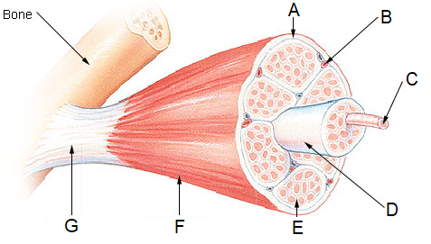

- The structure shown at location G best represents a

  - tendon.
  - ligament.
  - muscle fibre.
  - myofilament.

- The semi-lunar valves found in the heart prevent backflow of blood into the

  - atria.
  - ventricles.
  - pulmonary veins and arteries.
  - aorta and vena cava.

- Which of the following is not considered to be part of the excretory system?

  - Lungs
  - Liver
  - Skin
  - Stomach

- Which of the following describes the importance of a synergist in muscle movement?

  - Allows for more than one movement to occur at a time
  - Ensures that only one movement can occur at a time
  - Is the antagonist which opposes the movement of the agonist muscle
  - Acts as the prime mover in creating movement

- Which of the following substances is directly absorbed into the lymphatic system during digestion?

  - Glucose
  - Water
  - Amino acids
  - Fatty acids and glycerol

- A laboratory technician forgot to label a cross section of a blood vessel. Which of the following descriptions would help the technician to classify the vessel?

  - Veins have small lumens, which keep blood pressure high throughout the circulatory system.
  - Capillary walls are thick, which help resist the high pressure in capillary beds.
  - Veins contain the same three layers as arteries, but have less smooth muscle and elastic tissue.
  - Arteries contain valves to help push the blood away from the heart.

- A microscope with an objective lens of 10X and an eyepiece lens of 4X, has a field of view of 3500 µm. If the eyepiece lens is changed to 10X, what is the new field of view?

  - 8750 µm
  - 14 000 µm
  - 35 000 µm
  - 1400 µm

End of Section One

Section Two: Short answer 50% (106 Marks)

This section has 8 questions. Answer all questions. Write your answers in the spaces provided.

Supplementary pages for planning/continuing your answers to questions are provided at the end of this Question/Answer booklet. If you use these pages to continue an answer, indicate at the original answer where the answer is continued, i.e. give the page number.

Suggested working time: 90 minutes.

Question 31 (15 marks)

Adenosine triphosphate (ATP) provides the energy for the basic functions and cellular processes that occur within the human body.

- Describe the structure of ATP and explain how it can both store and release energy.
(5 marks)

___________________________________________________________________
___________________________________________________________________
___________________________________________________________________
___________________________________________________________________
___________________________________________________________________
___________________________________________________________________
___________________________________________________________________

Basal metabolic rate (BMR) is the measurement of energy required to perform basic functions such as movement and digestion.

- State the basic structure of the mammalian heart and explain how this structure relates to the high BMR seen in humans.
(4 marks)

___________________________________________________________________
___________________________________________________________________
___________________________________________________________________
___________________________________________________________________
___________________________________________________________________
- Crohn’s disease is a gastrointestinal disorder in which the villi of the small intestine become atrophied, breaking down and wasting away.

Explain why a person with Crohn’s disease would suffer from malabsorption and state three nutrients they would most likely be deficient in.
(5 marks)

___________________________________________________________________
___________________________________________________________________
___________________________________________________________________
___________________________________________________________________
___________________________________________________________________
___________________________________________________________________
___________________________________________________________________
___________________________________________________________________

- State the name given to the lymph capillary that is found within the villi.
(1 mark)

___________________________________________________________________

This page has been left blank intentionally

Question 32 (13 marks)

A group of Year 11 Human Biology students decided to investigate the relationship between the height of an individual and their lung capacity in both males and females. 100 subjects (50 males and 50 females) of the same age group were selected, and divided into height ranges. The Expiratory Reserve Volume (ERV), which is the amount of air that can be forcefully exhaled after a normal breath out, was obtained by breathing into a balloon, measuring the circumference and converting that measurement to millilitres. This was undertaken three times per participant and the average ERV for each age range was calculated.

The results of the experiment are shown in the table below.

Height (cm) |  | 156 - 160 | 161 – 165 | 166 - 170
ERV (mL) | Male | 1213 | 1387 | 1393
 | Female | 832 | 916 | 948

- Identify the following variables for the students’ investigation:
(2 marks)
  - Independent.

______________________________________________________________
______________________________________________________________

  - Dependent.

______________________________________________________________
______________________________________________________________

- Propose a hypothesis for which gender has the largest ERV.
(1 mark)

___________________________________________________________________
______________________________________________________________________________________________________________________________________

- Graph the results from the table on page 12 onto the grid provided below.
(5 marks)
A spare grid can be found on page 39.

- Describe one reason why increasing the height of an individual increases their ERV.
(2 marks)

___________________________________________________________________
______________________________________________________________________________________________________________________________________
___________________________________________________________________

- As this investigation was conducted on humans, describe one ethical requirement that would need to be considered.
(2 marks)

___________________________________________________________________
______________________________________________________________________________________________________________________________________
___________________________________________________________________

- State one change to this investigation that would increase the validity of the results.
(1 mark)

___________________________________________________________________
___________________________________________________________________

Question 33 (13 marks)

- Multicellular organisms, such as humans, involve a hierarchical organisation working together to maintain life.

Using an example, describe how cells, tissues and organs are related.
(3 marks)

___________________________________________________________________
______________________________________________________________________________________________________________________________________
______________________________________________________________________________________________________________________________________
___________________________________________________________________

- The internal environment of a cell is separated from the external environment by a thin membrane that regulates the movement of substances into and out of the cell.

In the space below, create a fully labelled diagram that identifies the main structures of the plasma membrane that are involved in the transport of substances.
(5 marks)

- Explain, making reference to the importance of concentration gradients, how oxygen and carbon dioxide levels are maintained in the lungs.
(4 marks)

___________________________________________________________________
______________________________________________________________________________________________________________________________________
______________________________________________________________________________________________________________________________________
______________________________________________________________________________________________________________________________________
___________________________________________________________________

- State the reason that carbon dioxide moves across the alveolar membrane much faster than oxygen.
(1 mark)

___________________________________________________________________
___________________________________________________________________

Question 34 (14 marks)

Gallbladder removal is often the only choice for patients suffering significant pain and other complications associated with the organ.

- Besides a reduction in fat intake, identify two suggestions a doctor may make about a patient’s diet after having their gallbladder removed.
(2 marks)

___________________________________________________________________
___________________________________________________________________

- Suggest why someone would reduce their fat intake after having their gallbladder removed.
(2 marks)

___________________________________________________________________
______________________________________________________________________________________________________________________________________
___________________________________________________________________

- Besides the gallbladder, describe how one other accessory organ aids in the process of digestion.
(3 marks)

___________________________________________________________________
______________________________________________________________________________________________________________________________________
______________________________________________________________________________________________________________________________________
___________________________________________________________________

Peristaltic muscular waves occur in many hollow tubes of the body, such as the oesophagus, stomach and intestines.

- State the three layers of muscle found in the stomach.
(1 mark)

___________________________________________________________________
___________________________________________________________________

- Explain how the muscle fibres of the stomach contract.
(6 marks)

______________________________________________________________________________________________________________________________________

______________________________________________________________________________________________________________________________________

______________________________________________________________________________________________________________________________________

______________________________________________________________________________________________________________________________________

______________________________________________________________________________________________________________________________________

______________________________________________________________________________________________________________________________________

Question 35 (12 marks)

- For each of the following factors, draw a line graph which depicts its effect on the activity of enzymes.

  - Temperature, with an optimal activity at 40 ºC.
(1 mark)

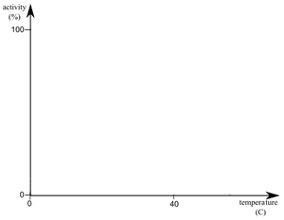

  - pH, with an optimal activity of pH 3.
(1 mark)

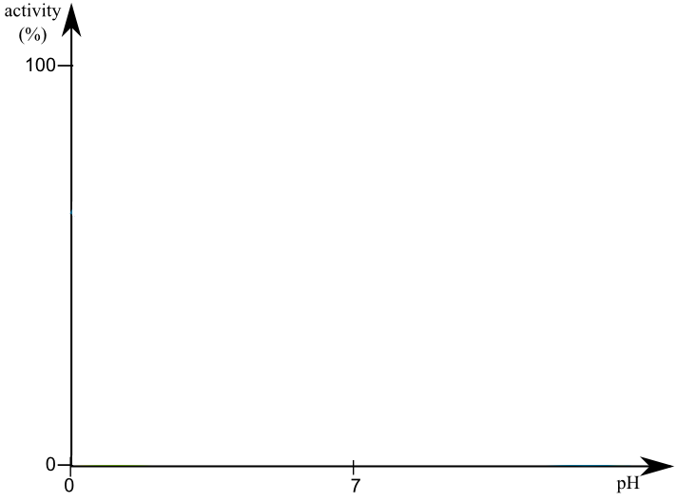

- Describe and explain how the concentrations of reactants and products can affect an enzyme’s rate of reaction.
(5 marks)

___________________________________________________________________

______________________________________________________________________________________________________________________________________
______________________________________________________________________________________________________________________________________
______________________________________________________________________________________________________________________________________

___________________________________________________________________

- Enzymes are found all over the body. Explain how enzymes normally found in the blood could also be located in the lymphatic system.
(3 marks)

______________________________________________________________________________________________________________________________________
______________________________________________________________________________________________________________________________________
______________________________________________________________________________________________________________________________________

- Lymph contains a high number of macrophages. Describe the role of these cells within the lymphatic system.
(2 marks)

______________________________________________________________________________________________________________________________________
______________________________________________________________________________________________________________________________________

Question 36 (14 marks)

Hip dysplasia occurs due to the incorrect development of the hip joint. It is often detected in babies, but can go unnoticed until adolescence and adulthood.

- Identify which classification the hip joint belongs to.
(2 marks)

______________________________________________________________________________________________________________________________________

- Describe a surgical treatment that a patient suffering hip dysplasia could undertake to help lessen the symptoms.
(2 marks)

______________________________________________________________________________________________________________________________________
______________________________________________________________________________________________________________________________________

- The types of movement occurring at a joint can be described by a number of terms. Complete the following table.
(5 marks)

Term | Movement | Example
 | Decreases the angle between articulating bones
 | Movement of bone around its long axis | Moving the head to the left and the right
Abduction

The skeletal framework aids in the production of movement and can be divided into two sections.
- Differentiate between the bones of the axial and appendicular skeleton.
(2 marks)

______________________________________________________________________________________________________________________________________
______________________________________________________________________________________________________________________________________

- The diagram below shows the structure of a section of compact bone.

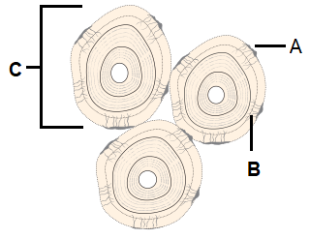

- State the name given to the individual units, labelled C, which make up compact bone.
(1 mark)

______________________________________________________________

- Identify and state the function of the tiny canals, labelled B.
(2 marks)

__________________________________________________________________________________________________________________________________________________________________________________________

Question 37 (13 marks)

The cells of a tissue found in the respiratory system are show below.

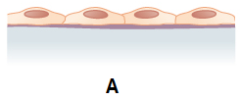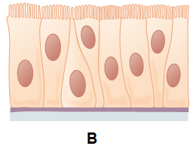

- Explain how the structure of the cells labelled B is suited to its function and state where they can be found in the respiratory system.
(3 marks)

______________________________________________________________________________________________________________________________________
______________________________________________________________________________________________________________________________________
______________________________________________________________________________________________________________________________________

- State the structure of the respiratory system that the cells labelled A would make up.
(1 mark)

___________________________________________________________________

- Explain how the structure identified in part (b) is well suited to its function.
(3 marks)

______________________________________________________________________________________________________________________________________
______________________________________________________________________________________________________________________________________
______________________________________________________________________________________________________________________________________
- Identify the two types of cellular respiration which occur in humans and differentiate between these processes.
(4 marks)

______________________________________________________________________________________________________________________________________
______________________________________________________________________________________________________________________________________
______________________________________________________________________________________________________________________________________
______________________________________________________________________________________________________________________________________

- Describe how the physical nature of the product/s of anaerobic respiration affect their movement across the cell membrane.
(2 marks)

______________________________________________________________________________________________________________________________________
______________________________________________________________________________________________________________________________________

Question 38 (12 marks)

The diagram below shows different organs associated with the digestive system.

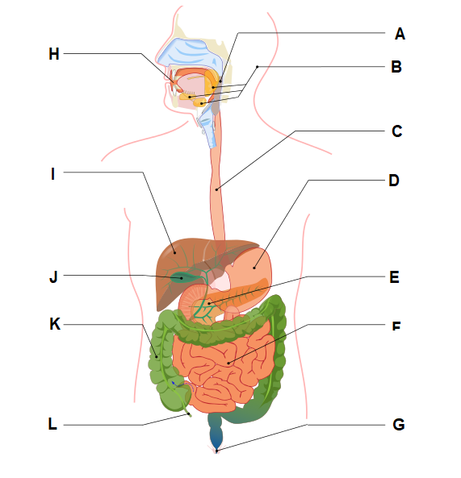

- State the name of the organs labelled:
(2 marks)

C: _________________________________________________________________

D: _________________________________________________________________

- Describe the functions of the organ labelled K.
(2 marks)

______________________________________________________________________________________________________________________________________
______________________________________________________________________________________________________________________________________

- Identify the enzyme produced in the organ labelled E that breaks down fats and state one issue that shortage of this enzyme may cause.
(2 marks)

______________________________________________________________________________________________________________________________________
______________________________________________________________________________________________________________________________________

The autonomic nervous system controls the muscular actions of the digestive system.

- State the name of the specialised cells found within nervous tissue and describe why these cells are microscopic.
(3 marks)

______________________________________________________________________________________________________________________________________
______________________________________________________________________________________________________________________________________
______________________________________________________________________________________________________________________________________

- Cell death, otherwise known as apoptosis, is associated with the release of digestive enzymes into the cytoplasm.

Outline how cell organelles are involved in apoptosis.
(3 marks)

______________________________________________________________________________________________________________________________________
______________________________________________________________________________________________________________________________________
______________________________________________________________________________________________________________________________________

End of Section Two

This page has been left blank intentionally

Section Three: Extended answer 20% (40 Marks)
This section contains three questions. You must answer two questions. Write your answers on the pages following Question 41.
Supplementary pages for planning/continuing your answers to questions are provided at the end of this Question/Answer booklet. If you use these pages to continue an answer, indicate at the original answer where the answer is continued, i.e. give the page number.
Suggested working time: 50 minutes.

Answer any two questions from Questions 39 to 41.

Indicate the questions you will answer by ticking the box next to the question. Write your answers on the pages that follow.

Question 39 (20 marks)

- By the year 2050, it is expected that approximately 25% of Australia’s population will be over 65 years of age.

Osteoporosis and osteoarthritis are chronic diseases associated with ageing that result in disability. For each of these diseases, describe the effect on the musculoskeletal system, the main symptoms experienced by an affected individual, and outline a practice that aids in its prevention.
(10 marks)

- As you age, your kidneys and bladder undergo changes. A decrease in the number of nephrons in the kidney is common and can lead to chronic kidney disease.

Explain the processes involved in the formation of urine, and state how chronic kidney disease would affect the volume of urine produced.
(10 marks)

Question 40 (20 marks)

The digestive system functions to breakdown and absorb required nutrients that are used by cells for biochemical processes.
- Explain why mechanical digestion must occur before chemical digestion.
(4 marks)

- Contrast anabolic and catabolic reactions in a cell, giving an example of each, and explain how these biochemical processes are controlled.
(8 marks)

- Biochemical processes within all systems of the body and the digestive system itself results in the production of wastes.

Explain the difference between elimination and excretion, and describe how amino acids are excreted from the body.
(8 marks)

Question 41 (20 marks)

- The circulatory system is sometimes compared to that of a busy transportation system due to the link between the internal environments of the body.

Describe the structure of blood and explain how blood is used as a medium to transport oxygen, carbon dioxide and nutrients around the body.
(12 marks)

- A meniscus tear of the knee is a common cartilage injury in sports such as AFL and basketball. Depending on the severity of the injury, some players may be told not to play sport for up to 8 weeks, others will require surgery and take up to 3 months to heal.

Describe the microscopic structure of cartilage and explain why injured cartilage takes longer to heal than bone.
(8 marks)

End of Section Three
Question number: ________________
__________________________________________________________________________________________________________________________________________________
_________________________________________________________________________
_________________________________________________________________________
_________________________________________________________________________
_________________________________________________________________________
__________________________________________________________________________________________________________________________________________________
_________________________________________________________________________
_________________________________________________________________________
_________________________________________________________________________
_________________________________________________________________________
__________________________________________________________________________________________________________________________________________________
_________________________________________________________________________
_________________________________________________________________________
_________________________________________________________________________
_________________________________________________________________________
__________________________________________________________________________________________________________________________________________________
_________________________________________________________________________
_________________________________________________________________________
_________________________________________________________________________
_________________________________________________________________________
__________________________________________________________________________________________________________________________________________________

Question number: ________________
__________________________________________________________________________________________________________________________________________________
_________________________________________________________________________
_________________________________________________________________________
_________________________________________________________________________
_________________________________________________________________________
__________________________________________________________________________________________________________________________________________________
_________________________________________________________________________
_________________________________________________________________________
_________________________________________________________________________
_________________________________________________________________________
__________________________________________________________________________________________________________________________________________________
_________________________________________________________________________
_________________________________________________________________________
_________________________________________________________________________
_________________________________________________________________________
__________________________________________________________________________________________________________________________________________________
_________________________________________________________________________
_________________________________________________________________________
_________________________________________________________________________
_________________________________________________________________________
_________________________________________________________________________
_________________________________________________________________________

Question number: ________________
__________________________________________________________________________________________________________________________________________________
_________________________________________________________________________
_________________________________________________________________________
_________________________________________________________________________
_________________________________________________________________________
__________________________________________________________________________________________________________________________________________________
_________________________________________________________________________
_________________________________________________________________________
_________________________________________________________________________
_________________________________________________________________________
__________________________________________________________________________________________________________________________________________________
_________________________________________________________________________
_________________________________________________________________________
_________________________________________________________________________
_________________________________________________________________________
__________________________________________________________________________________________________________________________________________________
_________________________________________________________________________
_________________________________________________________________________
_________________________________________________________________________
_________________________________________________________________________
_________________________________________________________________________
_________________________________________________________________________

Question number: ________________
__________________________________________________________________________________________________________________________________________________
_________________________________________________________________________
_________________________________________________________________________
_________________________________________________________________________
_________________________________________________________________________
__________________________________________________________________________________________________________________________________________________
_________________________________________________________________________
_________________________________________________________________________
_________________________________________________________________________
_________________________________________________________________________
__________________________________________________________________________________________________________________________________________________
_________________________________________________________________________
_________________________________________________________________________
_________________________________________________________________________
_________________________________________________________________________
__________________________________________________________________________________________________________________________________________________
_________________________________________________________________________
_________________________________________________________________________
_________________________________________________________________________
_________________________________________________________________________
_________________________________________________________________________
_________________________________________________________________________

Question number: ________________
__________________________________________________________________________________________________________________________________________________
_________________________________________________________________________
_________________________________________________________________________
_________________________________________________________________________
_________________________________________________________________________
__________________________________________________________________________________________________________________________________________________
_________________________________________________________________________
_________________________________________________________________________
_________________________________________________________________________
_________________________________________________________________________
__________________________________________________________________________________________________________________________________________________
_________________________________________________________________________
_________________________________________________________________________
_________________________________________________________________________
_________________________________________________________________________
_________________________________________________________________________
_________________________________________________________________________
_________________________________________________________________________
_________________________________________________________________________
_________________________________________________________________________
__________________________________________________________________________________________________________________________________________________
_________________________________________________________________________

Question number: ________________
__________________________________________________________________________________________________________________________________________________
_________________________________________________________________________
_________________________________________________________________________
_________________________________________________________________________
_________________________________________________________________________
__________________________________________________________________________________________________________________________________________________
_________________________________________________________________________
_________________________________________________________________________
_________________________________________________________________________
_________________________________________________________________________
__________________________________________________________________________________________________________________________________________________
_________________________________________________________________________
_________________________________________________________________________
_________________________________________________________________________
_________________________________________________________________________
__________________________________________________________________________________________________________________________________________________
_________________________________________________________________________
_________________________________________________________________________
_________________________________________________________________________
__________________________________________________________________________________________________________________________________________________
_________________________________________________________________________

Question number: ________________
__________________________________________________________________________________________________________________________________________________
_________________________________________________________________________
_________________________________________________________________________
_________________________________________________________________________
_________________________________________________________________________
__________________________________________________________________________________________________________________________________________________
_________________________________________________________________________
_________________________________________________________________________
_________________________________________________________________________
_________________________________________________________________________
__________________________________________________________________________________________________________________________________________________
_________________________________________________________________________
_________________________________________________________________________
_________________________________________________________________________
_________________________________________________________________________
__________________________________________________________________________________________________________________________________________________
_________________________________________________________________________
_________________________________________________________________________
_________________________________________________________________________
_________________________________________________________________________
_________________________________________________________________________
_________________________________________________________________________

Additional Working
__________________________________________________________________________________________________________________________________________________
_________________________________________________________________________
_________________________________________________________________________
_________________________________________________________________________
_________________________________________________________________________
__________________________________________________________________________________________________________________________________________________
_________________________________________________________________________
_________________________________________________________________________
_________________________________________________________________________
_________________________________________________________________________
__________________________________________________________________________________________________________________________________________________
_________________________________________________________________________
_________________________________________________________________________
_________________________________________________________________________
_________________________________________________________________________
__________________________________________________________________________________________________________________________________________________
_________________________________________________________________________
_________________________________________________________________________
_________________________________________________________________________
_________________________________________________________________________
_________________________________________________________________________
_________________________________________________________________________

Additional Working
__________________________________________________________________________________________________________________________________________________
_________________________________________________________________________
_________________________________________________________________________
_________________________________________________________________________
_________________________________________________________________________
__________________________________________________________________________________________________________________________________________________
_________________________________________________________________________
_________________________________________________________________________
_________________________________________________________________________
_________________________________________________________________________
__________________________________________________________________________________________________________________________________________________
_________________________________________________________________________
_________________________________________________________________________
_________________________________________________________________________
_________________________________________________________________________
__________________________________________________________________________________________________________________________________________________
_________________________________________________________________________
_________________________________________________________________________
_________________________________________________________________________
_________________________________________________________________________
_________________________________________________________________________
_________________________________________________________________________

Spare Grid

ACKNOWLEDGEMENTS

Question 5 Adapted from Ruiz Villarreal, M. (2007). …. in cell membrane [Image]. Retrieved November, 2018, from: https://commons.wikimedia.org/wiki/File:Scheme_..._in_cell_membrane-en.svg

Question 19 Adapted from Nossedotti (Anderson Birto). (2011). Viral … [Image]. Retrieved November, 2018, from: https://commons.wikimedia.org/wiki/File:Viral_...._(..._and_fusion).svg

Question 24 Adapted from Public Domain (2006). Structure of a Skeletal Muscle. [Image]. Retrieved December, 2018, from: https://commons.wikimedia.org/w/index.php?curid=1197565

Question 35 Adapted from Gal, M. (2007). Graph of Enzyme Activity against Temperature [Image]. Retrieved November, 2018, from:
https://commons.wikimedia.org/wiki/File:Enzyme-temperature.png

Adapted from Gal, M. (2007). Graph of Enzyme Activity against pH [Image]. Retrieved February, 2019, from:
https://commons.wikimedia.org/wiki/File:Enzyme-ph.png

Question 36 Adapted from Cancer Research UK (2014). Diagram of an … – a type of bone cell. [Image]. Retrieved November, 2018, from: https://commons.wikimedia.org/wiki/File:Diagram_of_an_..._-_a_type_of_bone_cell_CRUK_031.svg

Question 37 Adapted from OpenStax College (2013). Summary of … Tissue. [Image]. Retrieved November, 2018, from: https://commons.wikimedia.org/wiki/File:423_Table_04_02_Summary_of_..._Tissue_CellsN.jpg

Question 38 Adapted from Termininja (2012). Digestive System [Image]. Retrieved November, 2018, from: https://commons.wikimedia.org/wiki/File:Digestive_system.svg

